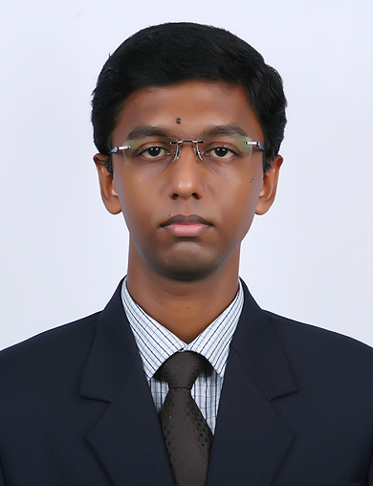
Harisankar.S harisankar.is@gmail.com Phone: +91 8943939191

CAREER OBJECTIVE:
I aspire to be a part of a dynamic, progressive and learning organization, where I can enrich in terms of input and provide ample scope for employing my abilities and knowledge to achieve excellent results and be a strong pillar of the organization.
WORK EXPERIENCE:
Currently working as Asst.Manager at HDFC Bank Ltd from May 4th 2015.
Roles & Responsibilities:
- Handling Exports, Imports, Outward Remittance & other trade related products.
- Timely and appropriate escalation of issues and suggest probable solution.
- Handling MIS and maintain TAT for disposal of received documents.
- Handling Retail / EEG/Corporate customers.
- Analysis of Audit report to avoid recurrence of comments.
- Continuous update on non-system related banking activities including constant Update on the changes / developments across banking industry.
- Following up on original documents/Retail FX docs and updations
- Understanding and quick implementation of new process roll outs
- Proper Record Maintenance / indexing for easy retrieval & warehousing
Previous
Worked as Business Analyst & Marketing Manager at Stat Decision Labs,Bangalore from April 2014 to April 2015

Marketing & Sales | - Helping management in forthcoming products and discuss on special promotions.  - Coordinating with the technical team for proper implementation and development of web based reporting portals/tools and automation projects.  - Recognize and reach out to clients in businesses.  - Identifies business opportunities by identifying prospects and evaluating their position in the industry; researching and analysing sales options
Business Analyst | - Monitors project progress by tracking activity; resolving problems; publishing progress reports and recommending actions using Tableau and SPSS.  - Conducting in-depth market analysis.
Product Management | Managing web based reporting portals like:  - Marketing Automation Solution  - Loyalty Management Solution  - Sales & Operational Analytics solution  - Card Analytics  - Footfall analyser

EDUCATIONAL QUALIFICATION:

Professional:
- Post Graduate Diploma in Management (PGDM) in Marketing and Retail Merchandise Management from School of Communication and Management studies (SCMS – Cochin) scoring 2.97 CGPA (74%).

- Bachelor of Engineering (B.E) in Information Science under Visvesvaraya Technological University, Belgaum from New Horizon College of Engineering and Technology, Bangalore, Karnataka with 60.1% aggregate.

Academic:

- Pre University -12th from Al-Ameen Public School, Edapally.

- Matriculation- 10th from St.Joseph Public School,Pattanakkad

PROJECT UNDERTAKEN:

PGDM PROJECT- Impact of Visual Merchandising on Consumer Behaviour

I had the opportunity to do my internship with Reliance Trends, Bangalore from 25th June 2012 to 8th September 2012. As part of the project I studied the impact of Visual Merchandising on Consumer Behaviour in the store. Also found out the areas of improvement and changes that can be bought about to improve Visual Merchandising.

ENGINEERING PROJECT – Agent based intrusion detection in Ad-hoc Network

My team successfully completed the development of software which can be used to find out the Agent based intrusion in an Ad-hoc Network. The software was developed on JAVA platform.

ACTIVITIES AND ACHIEVEMENTS:

- Participated in ‘Parivarthana 2011’, a CSR initiative of SCMS Group.

- Organized Brand Wars competition in ‘Shikhar ’,Management Fest of SCMS

- Coordinated National conference on Artificial Intelligence & Software Engineering (AISE) for the year 2009 & 2010
- Coordinated intercollege fest ‘Sargam’ organized by New Horizon College of Engineering.

- Undergone outbound training program under KALIPSO especially in hiking, boating and other team activities.
- Completed Strategic Management Course CAPSTONE.
- Has participated in inter-college Badminton tournaments (2009&2010).
- Has participated in inter-department Cricket & Volleyball matches (2008-2011).

PERSONAL DOSSIER

Date of Birth | : 18-05-1990 | Age | : 26
Marital Status: Single |  | Sex | : Male
Languages | : Malayalam, Hindi, English, Tamil

DECLARATION

I, hereby, certify that all the information provided above is true to the best of my knowledge and belief.

Place: Cochin HARISANKAR S.

